Azure Active Directory (AAD):

* AAD is a Microsoft enterprise cloud-based identity and accesses management (IAM) solution.
* Azure AD is the backbone of 365 system.
* For an organization azure AD helps employee’s signup to multiple services and accesses them anywhere over the cloud with a single set of login credentials.

* In Active directory we have created the app registration and will get the Application ID (ClientID) object ID and Directory ID.
* So, whatever the IDs we are getting that is sensible information, that should be stored in key vault (secrets) and giving access to other person or an application in access policy.

* In real time we are giving the group level access and individual, now we are creating the group in azure active directory.
* Azure group is the name of the group in azure AD.

* Owner (Surya) only can read, contribute and modify the group nothing but managing now we are adding members to the group.

* Now, we are giving access in resources like: APIM, AKS, virtual network and whatever the resources we are created.
* We are giving READ and CONTRIBUTE access in API resource.
* READ - View all resources but not allow to make CONTRIBUTE – Manage all the resources and can make changes.

Azure Devops:

* Devops is the combination development and operations are known as devops.
* Azure devops is a culture and set of processes that bring together developers, project managers and contributors to develop software.
* It allows organization to create and improve products.
* In devops we are using the CICD (continuous integration and continuous deliver) process to avoid dependency and time.
* Steps:

CD: continuous download

CI: continuous integration

CT: continuous testing

CD: continuous deployment

CD: continuous deliver

* We must install the AZ-CLI and kubeCTL.
* AZ-cli is used to manage many azure devops services from the command line.
* KubeCTL is a command line tool, and it is used to communicate and control Kubernetes clusters.
* We are deploying the Kubernetes cluster and connecting the cluster and creating the name spaces using AZ-cli and kubeCTL.
* We must connect through azure portal

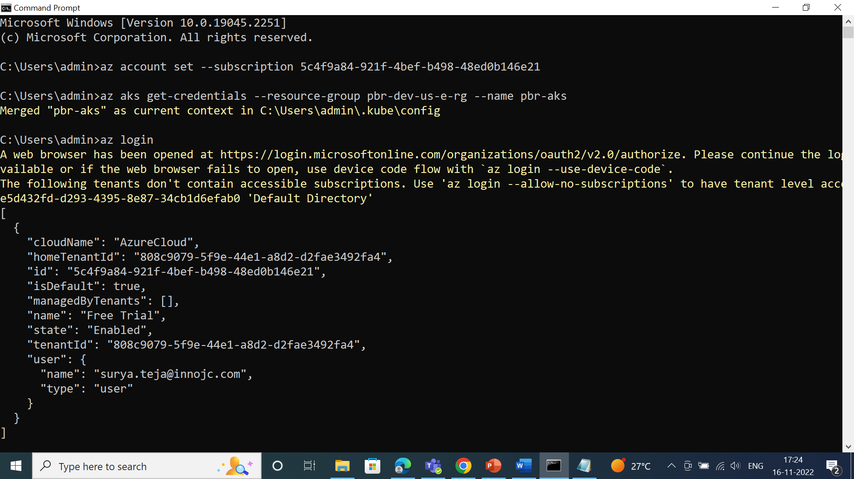

* Deploying the azure Kubernetes cluster

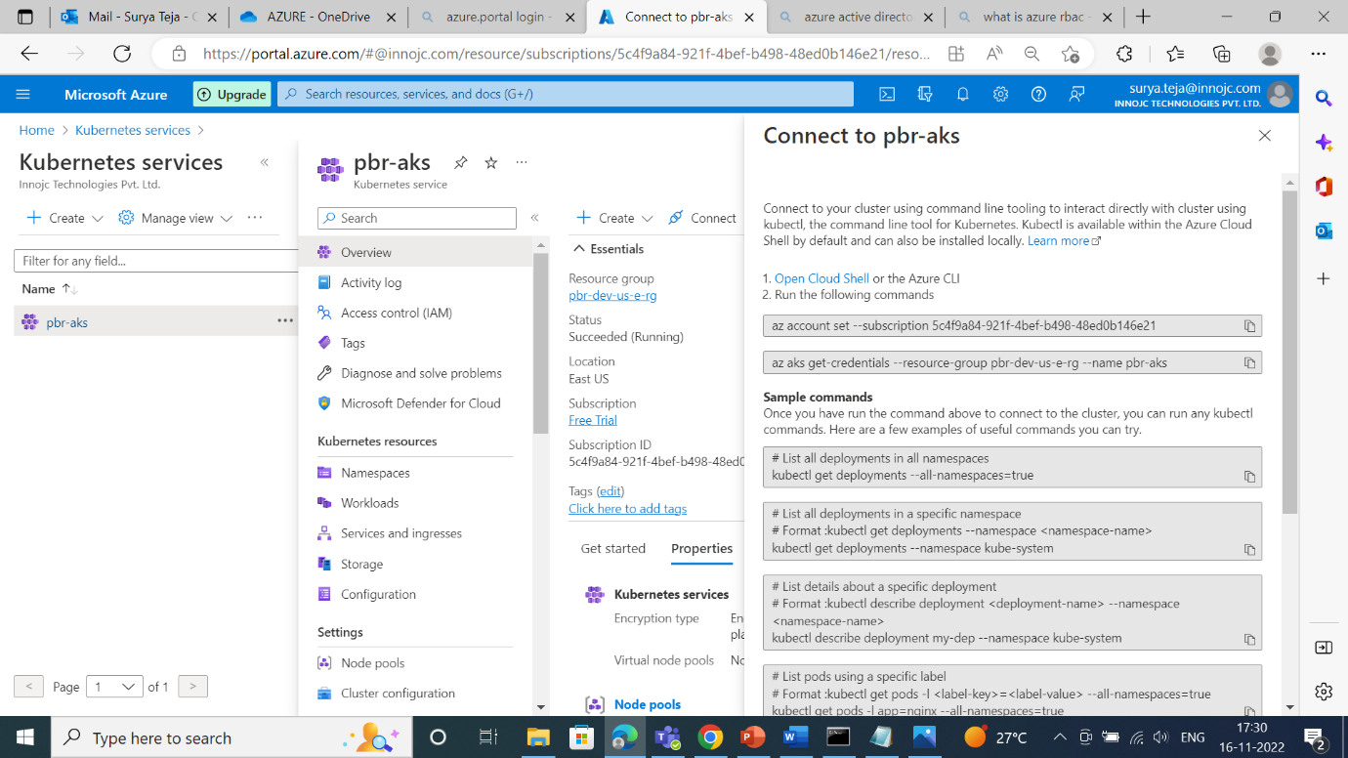

* After login into aks cluster the config file will be generated.
* Config file contains secured data and token information, and it will be generated with the help of client certificate data client key data and token.

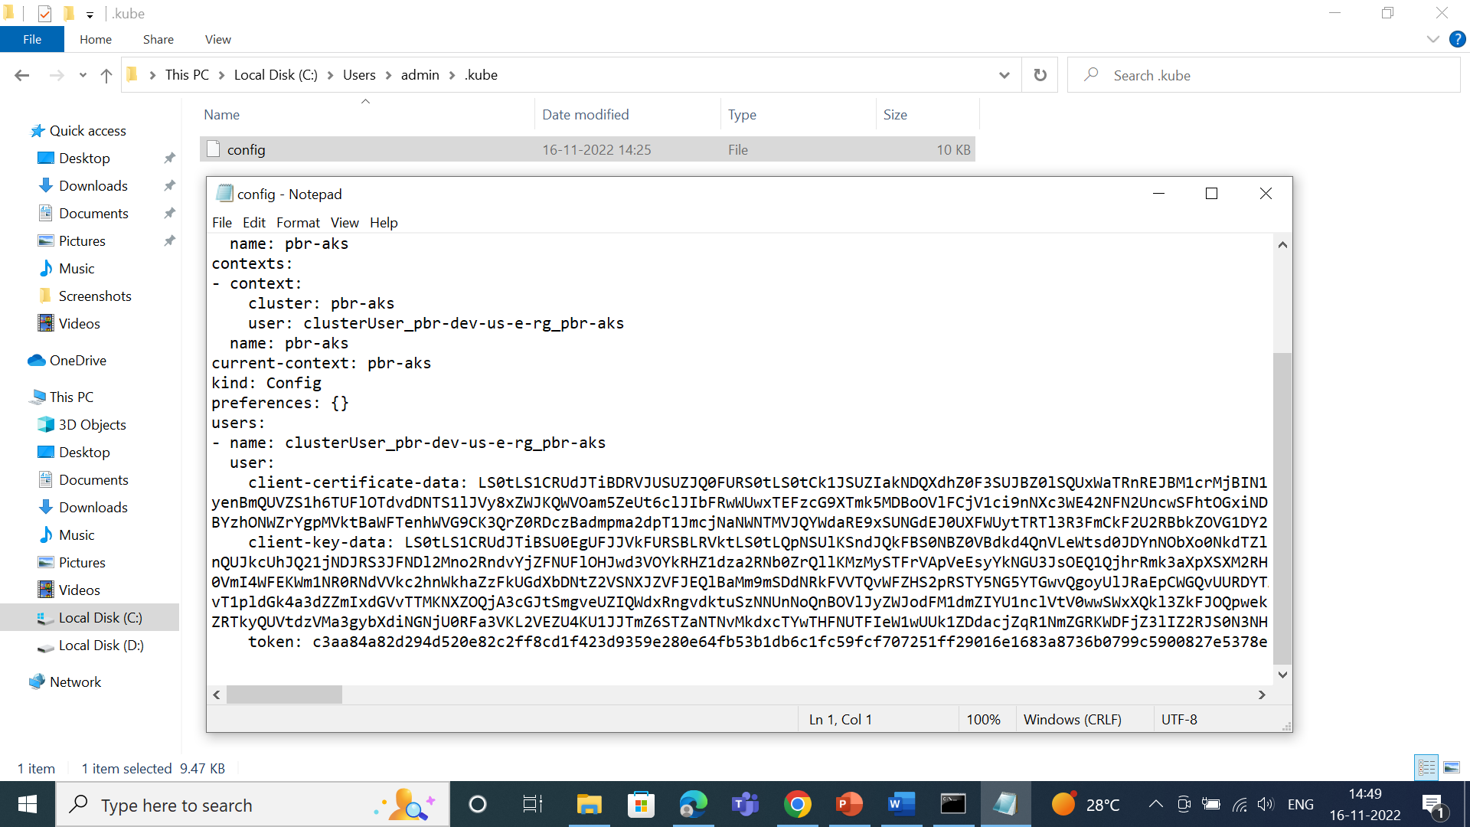

* When we launch AKS cluster by default, we get namespaces.
* Namespaces is nothing but organize cluster into virtual sub-clusters.
* Deploying the pods, pod is a small scale of deployment nothing but small program with the help of this we can deploy all our services.
* Commands >kubectl get namespaces

>kubectl get pods

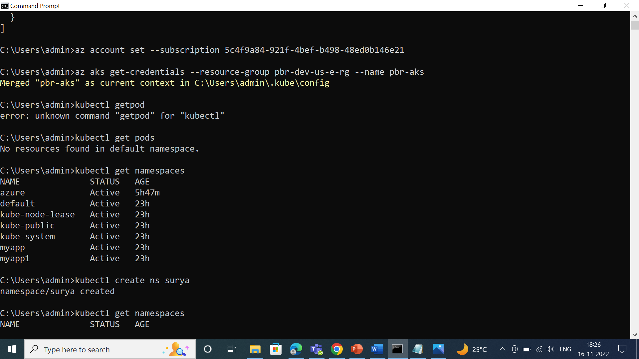

* We should not deploy services in default namespaces because due to security.

To create namespace command

>kubectl create ns surya

>kubectl get namespaces

To know the pod

>kubectl get pod -n myapp

To describe the whole pod information

>kubectl describe pod hello1 -n myapp

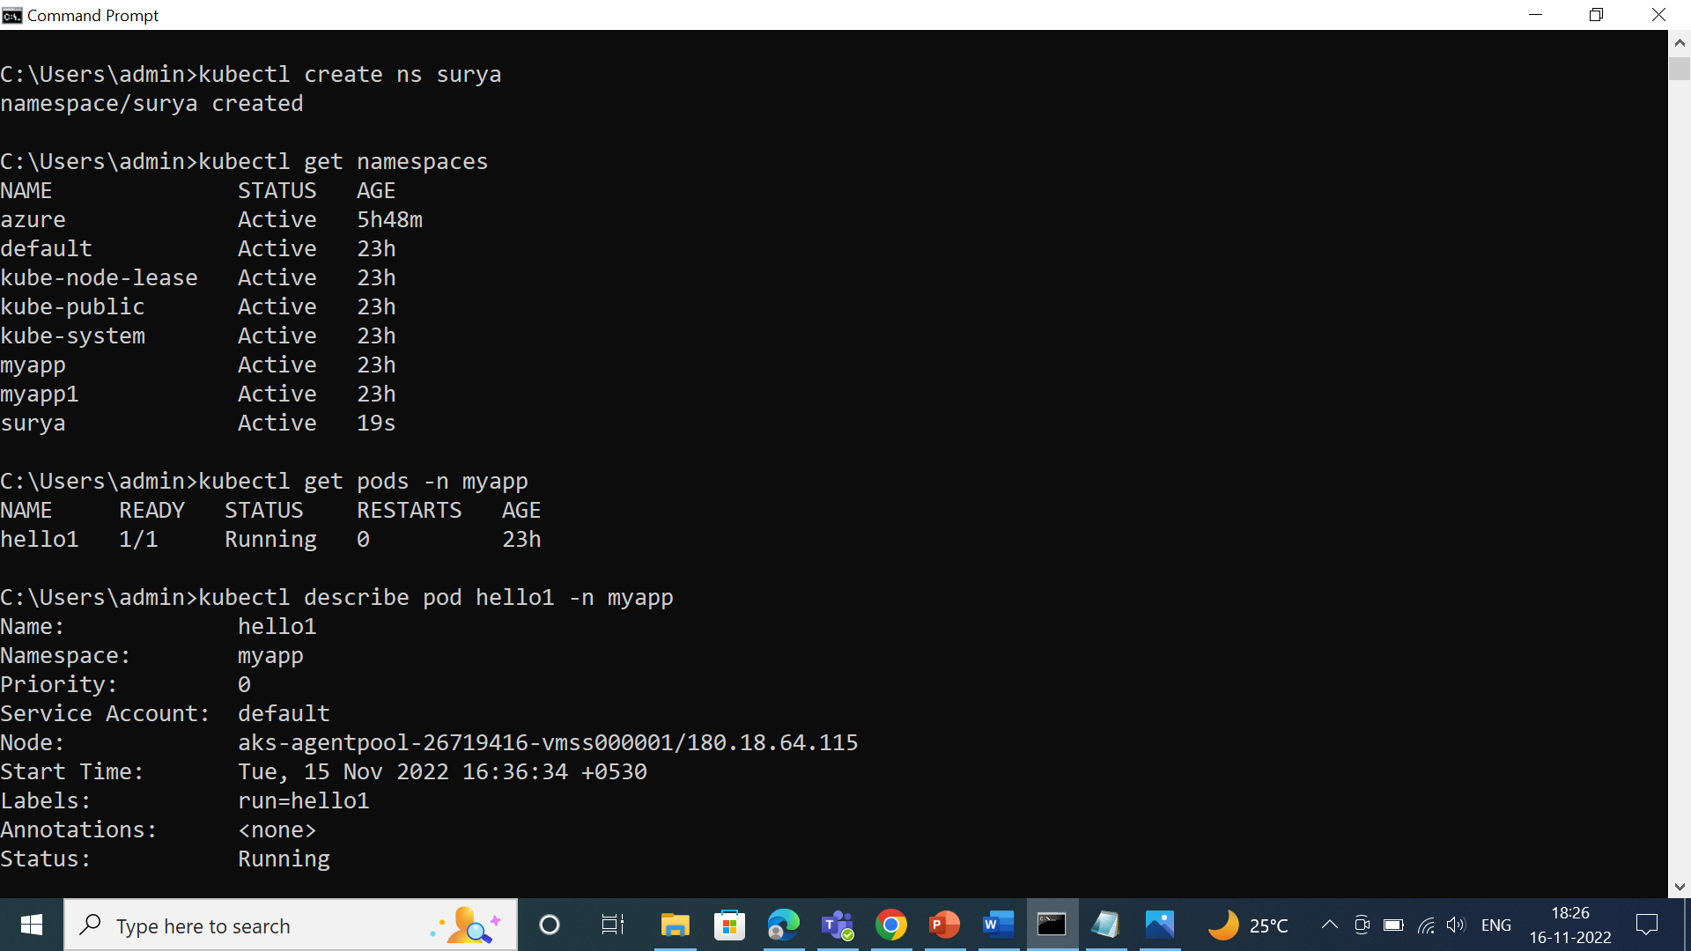

To know the deployment and services

>kubectl get deployment

>kubectl get services

